UIT2611 Mobile Application Development Lab

Reg no: 3122235002113
Name: Saranya S

EXP No: 1 STUDY AND INSTALLATION OF FLUTTER/KOTLIN MULTIPLATFORM ENVIRONMENT

AIM:
To study and install the Flutter SDK and configure the development environment for building cross-platform mobile applications.

PROCEDURE:
- Download the Flutter SDK from the official Flutter website.
- Extract the Flutter SDK to a suitable directory on the system.
- Add the Flutter bin directory to the system environment variables.
- Install Android Studio or Visual Studio Code.
- Install Flutter and Dart plugins in the IDE.
- Install Android SDK and create an Android emulator.
- Open command prompt or terminal and execute the command:
flutter doctor
- Resolve any issues reported by flutter doctor.
- Create a new Flutter project using:
flutter create ex1_install
- Run the application using:
flutter run

CODE:
main.dart
import 'package:flutter/material.dart';
void main() {
runApp(const MyApp());
}
class MyApp extends StatelessWidget {
const MyApp({super.key});
@override
Widget build(BuildContext context) {
return MaterialApp(
title: 'Flutter Demo',
theme: ThemeData(
colorScheme: .fromSeed(seedColor: Colors.deepPurple),
),
home: const MyHomePage(title: 'Flutter Demo Home Page'),
); }}
class MyHomePage extends StatefulWidget {
const MyHomePage({super.key, required this.title});
final String title;
@override
State<MyHomePage> createState() => _MyHomePageState();
}
class _MyHomePageState extends State<MyHomePage> {
int _counter = 0;
void _incrementCounter() {
setState(() {
_counter++;
}); }
@override
Widget build(BuildContext context) {
return Scaffold(
appBar: AppBar(
backgroundColor: Theme.of(context).colorScheme.inversePrimary,
title: Text(widget.title),
),
body: Center(
child: Column(
mainAxisAlignment: .center,
children: [
const Text('You have pushed the button this many times:'),
Text(
'$_counter',
style: Theme.of(context).textTheme.headlineMedium,
),],), ),
floatingActionButton: FloatingActionButton(
onPressed: _incrementCounter,
tooltip: 'Increment',
child: const Icon(Icons.add),
),);}}

OUTPUT:
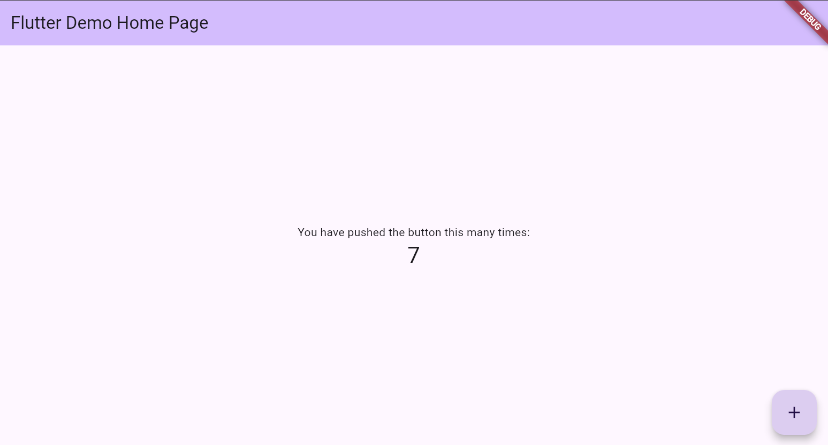

RESULT:
Flutter SDK was successfully installed and configured. The development environment was verified and a sample Flutter application was created and executed successfully.

EXP No : 2 DEVELOP AN APPLICATION THAT USES WIDGETS, GUI COMPONENTS, FONT AND COLORS

AIM:
To develop a Flutter application using basic widgets, custom fonts, and color themes to understand Flutter UI design.

CODE:
main.dart

import 'package:flutter/material.dart';
void main() {
runApp(BeautifulApp());
}
class BeautifulApp extends StatelessWidget {
@override
Widget build(BuildContext context) {
return MaterialApp(
debugShowCheckedModeBanner: false,
home: HomePage(),
);
}
}
class HomePage extends StatelessWidget {
@override
Widget build(BuildContext context) {
return Scaffold(
body: Container(
decoration: BoxDecoration(
gradient: LinearGradient(
colors: [Colors.blue.shade300, Colors.purple.shade400],
begin: Alignment.topLeft,
end: Alignment.bottomRight,
),
),
child: Center(
child: Card(
elevation: 10,
shape: RoundedRectangleBorder(
borderRadius: BorderRadius.circular(20),
),
child: Padding(
padding: const EdgeInsets.all(24.0),
child: Column(
mainAxisSize: MainAxisSize.min,
children: [
Icon(Icons.flutter_dash, size: 80, color: Colors.blue),
SizedBox(height: 16),
Text(
"Flutter UI Demo",
style: TextStyle(fontSize: 24, fontWeight: FontWeight.bold),
),
SizedBox(height: 8),
Text(
"Beautiful widgets with layout & colors",
textAlign: TextAlign.center,
),
SizedBox(height: 20),
ElevatedButton.icon(
onPressed: () {},
icon: Icon(Icons.arrow_forward),
label: Text("Get Started"),
)],),),),),),);}}

OUTPUT:

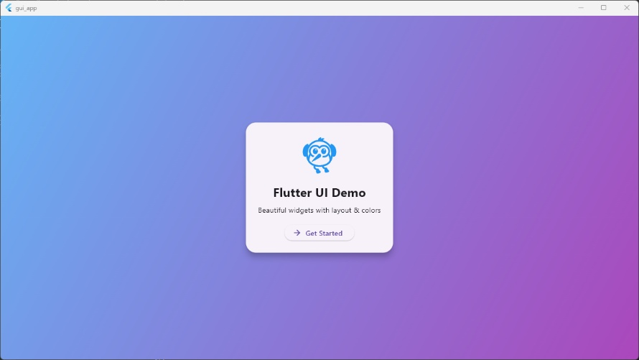

RESULT:
A Flutter application was successfully developed using various widgets, fonts, and colors. The application displayed a responsive and visually styled user interface.

EXP No : 3 DEVELOP A NATIVE CALCULATOR APPLICATION

AIM:
To design and develop a simple calculator application using Flutter to perform basic arithmetic operations.

CODE:
main.dart

import 'package:flutter/material.dart';
import 'package:math_expressions/math_expressions.dart';
void main() => runApp(const CalculatorApp());
class CalculatorApp extends StatelessWidget {
const CalculatorApp({super.key});
@override
Widget build(BuildContext context) {
return MaterialApp(
debugShowCheckedModeBanner: false,
title: 'Calculator',
theme: ThemeData(
primarySwatch: Colors.blueGrey,
),
home: const CalculatorHome(),
);
}
}
class CalculatorHome extends StatefulWidget {
const CalculatorHome({super.key});
@override
State<CalculatorHome> createState() => _CalculatorHomeState();
}
class _CalculatorHomeState extends State<CalculatorHome> {
String _input = '';
String _result = '';
final List<String> buttons = [
'C', '÷', '×', '←',
'7', '8', '9', '-',
'4', '5', '6', '+',
'1', '2', '3', '=',
'0', '.', '', '',
];
void _onPressed(String button) {
setState(() {
if (button == 'C') {
_input = '';
_result = '';
} else if (button == '←') {
if (_input.isNotEmpty) _input = _input.substring(0, _input.length - 1);
} else if (button == '=') {
_calculateResult();
} else {
_input += button;
}
});
}
void _calculateResult() {
try {
String finalInput = _input.replaceAll('×', '*').replaceAll('÷', '/');
Parser p = Parser();
Expression exp = p.parse(finalInput);
ContextModel cm = ContextModel();
double eval = exp.evaluate(EvaluationType.REAL, cm);
_result = eval % 1 == 0 ? eval.toInt().toString() : eval.toStringAsFixed(2);
} catch (e) {
_result = 'Error';
}
}
Color _getButtonColor(String button) {
if (button == 'C' || button == '←') return Colors.redAccent;
if (button == '=' || button == '+' || button == '-' || button == '×' || button == '÷') return Colors.blueGrey;
return Colors.grey[850]!;
}
Color _getTextColor(String button) {
if (button == 'C' || button == '←' || button == '=' || button == '+' || button == '-' || button == '×' || button == '÷') return Colors.white;
return Colors.white70;
}
@override
Widget build(BuildContext context) {
return Scaffold(
backgroundColor: Colors.black,
body: Column(
children: [
Expanded(
flex: 2,
child: Container(
padding: const EdgeInsets.all(20),
alignment: Alignment.bottomRight,
child: Column(
mainAxisAlignment: MainAxisAlignment.end,
crossAxisAlignment: CrossAxisAlignment.end,
children: [
Text(
_input,
style: const TextStyle(fontSize: 32, color: Colors.white70),
),
const SizedBox(height: 10),
Text(
_result,
style: const TextStyle(fontSize: 48, color: Colors.white, fontWeight: FontWeight.bold),
),
],
),
),
),
Expanded(
flex: 5,
child: Container(
padding: const EdgeInsets.all(10),
child: GridView.builder(
itemCount: buttons.length,
gridDelegate: const SliverGridDelegateWithFixedCrossAxisCount(
crossAxisCount: 4,
childAspectRatio: 1.1,
crossAxisSpacing: 10,
mainAxisSpacing: 10,
),
itemBuilder: (context, index) {
return buttons[index].isEmpty
? const SizedBox()
: ElevatedButton(
onPressed: () => _onPressed(buttons[index]),
style: ElevatedButton.styleFrom(
backgroundColor: _getButtonColor(buttons[index]),
shape: RoundedRectangleBorder(
borderRadius: BorderRadius.circular(12),
),
),
child: Text(
buttons[index],
style: TextStyle(
fontSize: 24,
color: _getTextColor(buttons[index]),
fontWeight: FontWeight.bold,
),
),
);
},
),
),
),
],
),
);
}
}

OUTPUT:
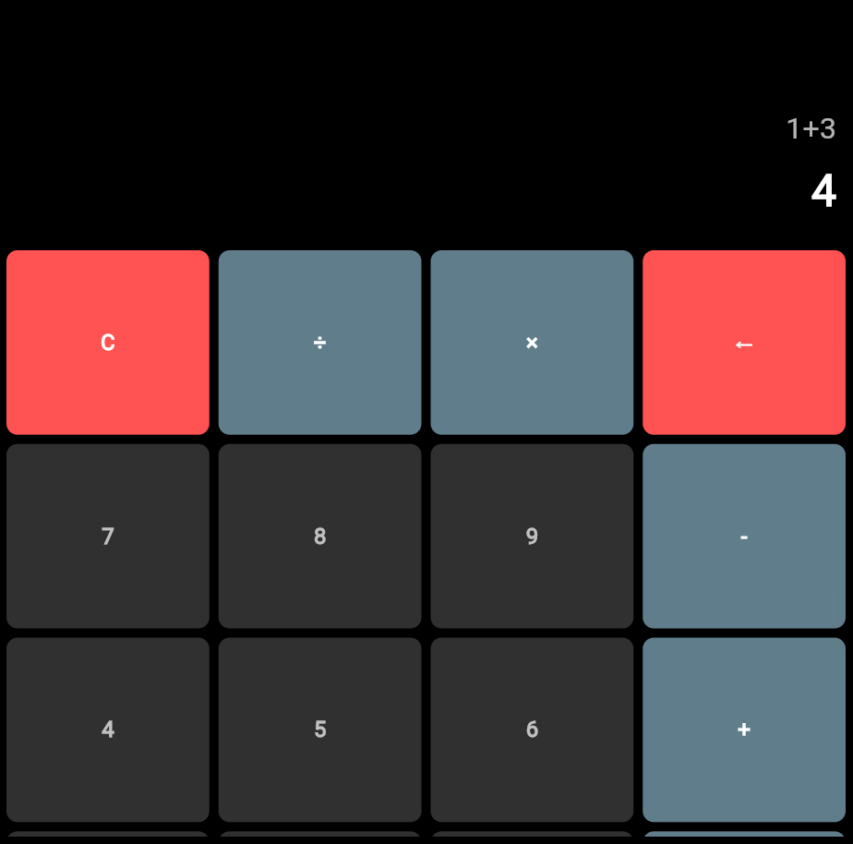

RESULT:
A calculator application was successfully developed that performs arithmetic operations such as addition. The user inputs were processed correctly and the results were displayed accurately.

EXP No : 4 DEVELOP A GAMING APPLICATION THAT USES 2-D ANIMATIONS AND GESTURES

AIM:
To develop a simple 2-D gaming application using Flutter with gesture detection and animation.

CODE:
main.dart
import 'dart:async';
import 'dart:math';
import 'package:flutter/material.dart';
void main() {
runApp(BallGame());
}
class BallGame extends StatefulWidget {
@override
_BallGameState createState() => _BallGameState();
}
class _BallGameState extends State<BallGame> {
double redX = 150;
double redY = 0;
int score = 0;
bool gameOver = false;
List<Map<String, double>> blueBalls = [];
Timer? gameTimer;
double screenWidth = 0;
double screenHeight = 0;
@override
void didChangeDependencies() {
super.didChangeDependencies();
final size = MediaQuery.of(context).size;
screenWidth = size.width;
screenHeight = size.height;
redY = screenHeight - 100; // bottom of screen
}
@override
void initState() {
super.initState();
startGame();
}
void startGame() {
gameTimer = Timer.periodic(Duration(milliseconds: 30), (timer) {
setState(() {
score++;
for (var ball in blueBalls) {
ball['y'] = ball['y']! + 6;
if ((ball['x']! - redX).abs() < 30 &&
(ball['y']! - redY).abs() < 30) {
gameOver = true;
timer.cancel();
}
}
// Remove balls that go off-screen
blueBalls.removeWhere((ball) => ball['y']! > screenHeight);
// Spawn new blue balls across FULL screen width
if (Random().nextInt(15) == 0) {
blueBalls.add({
'x': Random().nextDouble() * (screenWidth - 30),
'y': 0,
});
}
});
});
}
void restartGame() {
setState(() {
blueBalls.clear();
score = 0;
gameOver = false;
startGame();
});
}
@override
Widget build(BuildContext context) {
return MaterialApp(
debugShowCheckedModeBanner: false,
home: Scaffold(
body: GestureDetector(
onHorizontalDragUpdate: (details) {
setState(() {
redX += details.delta.dx;
redX = redX.clamp(0, screenWidth - 40);
});
},
child: Stack(
children: [
Container(color: Colors.black),
// Red player ball
Positioned(
left: redX,
top: redY,
child: CircleAvatar(
radius: 20,
backgroundColor: Colors.red,
),
),
// Blue falling balls
...blueBalls.map(
(ball) => Positioned(
left: ball['x']!,
top: ball['y']!,
child: CircleAvatar(
radius: 15,
backgroundColor: Colors.blue,
),
),
),
// Score
Positioned(
top: 40,
left: 20,
child: Text(
"Score: $score",
style: TextStyle(color: Colors.white, fontSize: 20),
),
),
// Game Over
if (gameOver)
Center(
child: Column(
mainAxisSize: MainAxisSize.min,
children: [
Text(
"GAME OVER",
style: TextStyle(
color: Colors.red,
fontSize: 40,
fontWeight: FontWeight.bold,
),
),
SizedBox(height: 20),
ElevatedButton(
onPressed: restartGame,
child: Text("Restart"),
)
],
),
)
],
),),),);}}

OUTPUT:
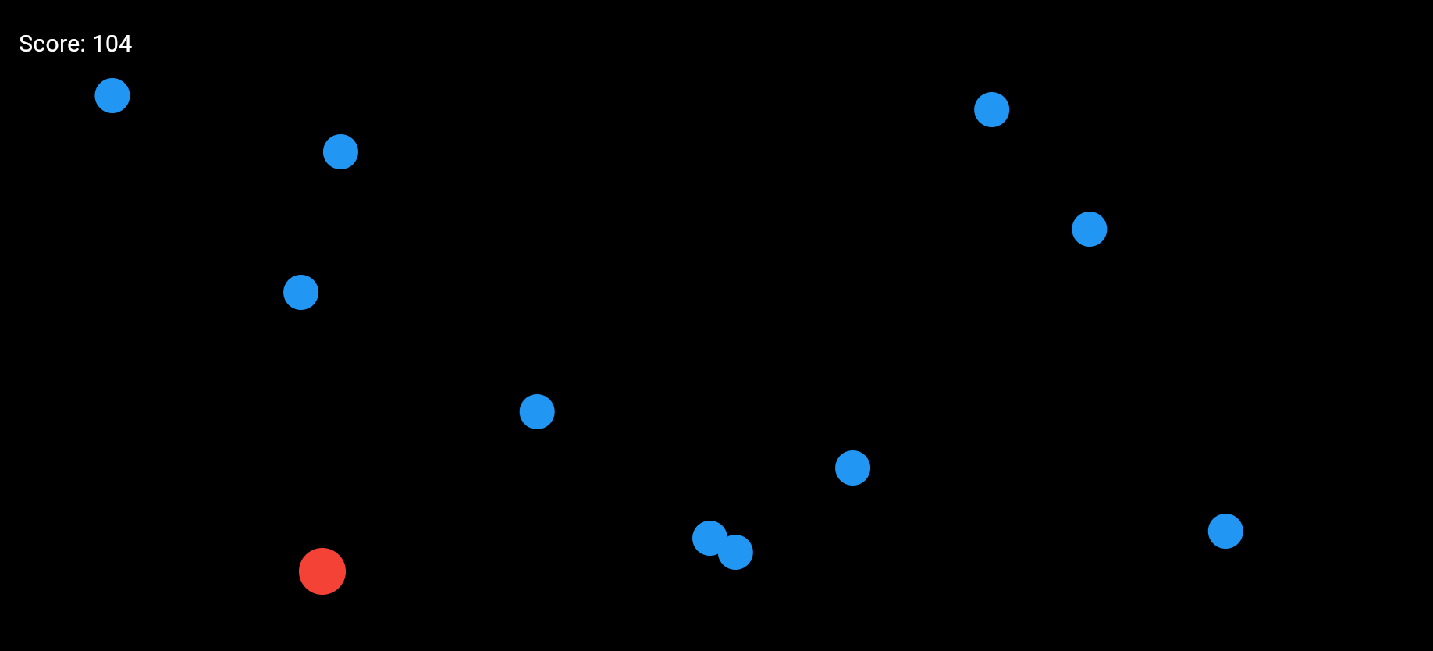
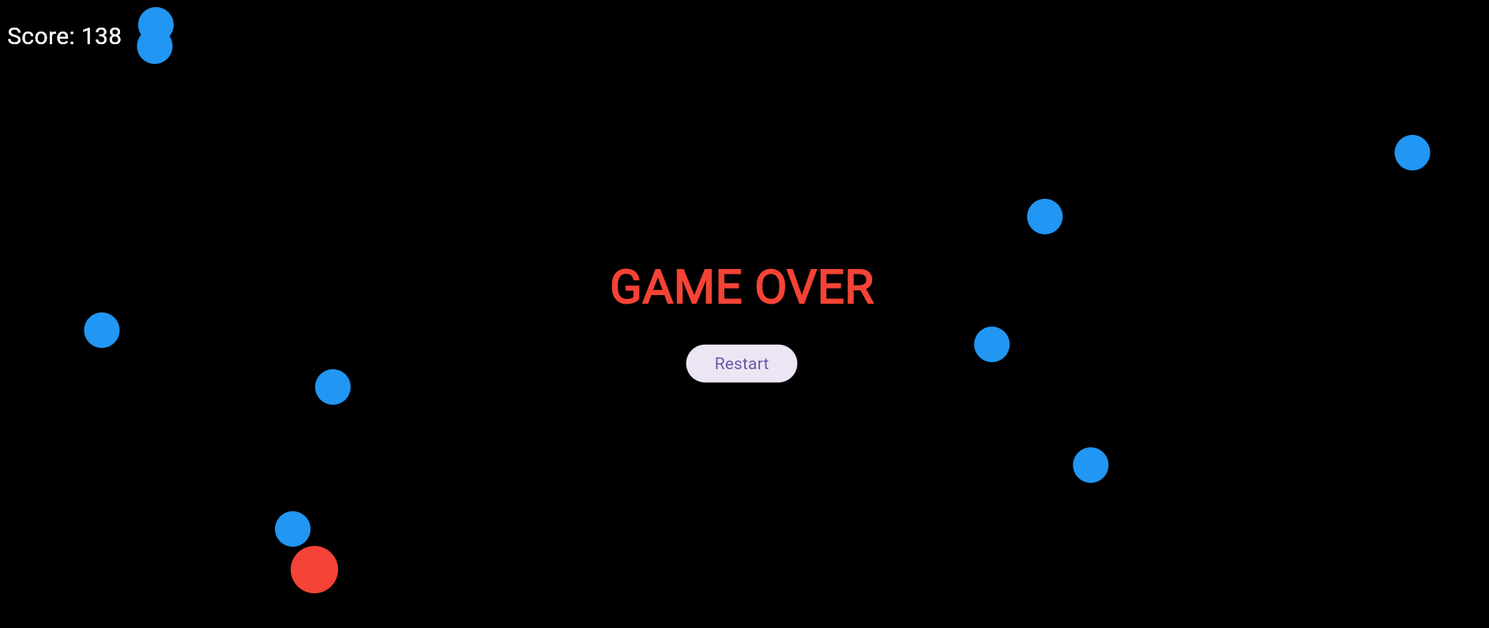

RESULT:
A basic 2-D game application was successfully implemented. The application responded correctly to user gestures and demonstrated movement using animations.

EXP No : 5 DEVELOP A MOVIE RATING APPLICATION (SIMILAR TO IMDB)

AIM:
To develop a movie rating application using Flutter that displays movie details and ratings.

CODE:
main.dart

import 'package:flutter/material.dart';
void main() {
runApp(MovieApp());
}
class MovieApp extends StatelessWidget {
final List<Map<String, String>> movies = [
{"title": "Inception", "rating": "8.8"},
{"title": "Interstellar", "rating": "8.6"},
{"title": "Joker", "rating": "8.5"},
{"title": "The Dark Knight", "rating": "9.0"},
{"title": "Avengers: Endgame", "rating": "8.4"},
{"title": "Fight Club", "rating": "8.8"},
{"title": "Forrest Gump", "rating": "8.8"},
{"title": "The Matrix", "rating": "8.7"},
{"title": "Gladiator", "rating": "8.5"},
{"title": "Titanic", "rating": "7.9"},
{"title": "The Godfather", "rating": "9.2"},
{"title": "Pulp Fiction", "rating": "8.9"},
{"title": "Avatar", "rating": "7.8"},
];
@override
Widget build(BuildContext context) {
return MaterialApp(
debugShowCheckedModeBanner: false,
home: Scaffold(
appBar: AppBar(title: Text("Movie Ratings")),
body: ListView.builder(
itemCount: movies.length,
itemBuilder: (context, index) {
return Card(
margin: EdgeInsets.all(10),
elevation: 5,
child: ListTile(
leading: Icon(Icons.movie, size: 40),
title: Text(
movies[index]['title']!,
style: TextStyle(fontWeight: FontWeight.bold),
),
trailing: Text(
"⭐ ${movies[index]['rating']}",
style: TextStyle(fontSize: 18),
),
),
);
},
),
),
);
}
}

OUTPUT:
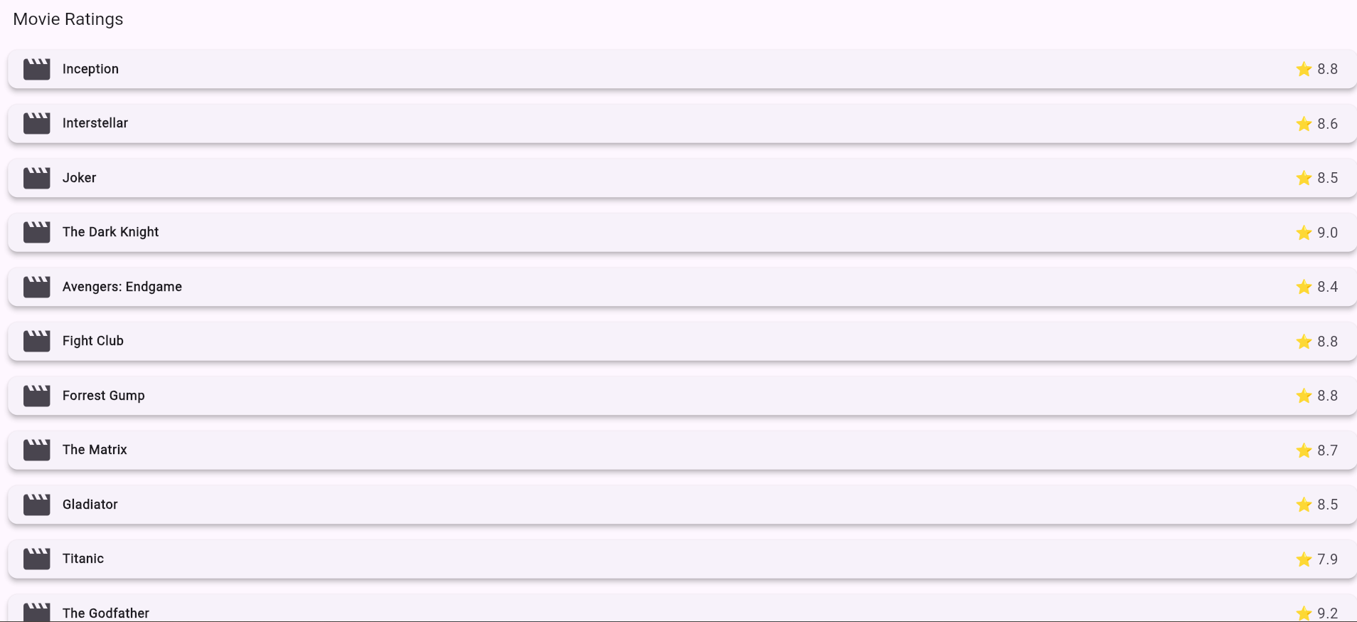

RESULT:
A movie rating application was successfully developed that displays a list of movies along with their ratings in a user-friendly interface.

EXP No : 6 DEVELOP A MOVIE RATING APPLICATION (SIMILAR TO IMDB)

AIM:
To develop a Flutter application that connects to a web service and retrieves data using HTTP requests.

CODE:
main.dart
import 'dart:convert';
import 'package:flutter/material.dart';
import 'package:http/http.dart' as http;
void main() {
runApp(const MyApp());
}
class MyApp extends StatelessWidget {
const MyApp({super.key});
@override
Widget build(BuildContext context) {
return const MaterialApp(
debugShowCheckedModeBanner: false,
home: HttpExample(),
);
}
}
class HttpExample extends StatefulWidget {
const HttpExample({super.key});
@override
State<HttpExample> createState() => _HttpExampleState();
}

class _HttpExampleState extends State<HttpExample> {
int postId = 0;
String title = "";
String body = "";
bool loading = true;
Future<void> fetchData() async {
final response = await http.get(
Uri.parse('https://jsonplaceholder.typicode.com/posts/1'),
);
if (response.statusCode == 200) {
final data = jsonDecode(response.body);
setState(() {
postId = data['id'];
title = data['title'];
body = data['body'];
loading = false;
});
} else {
setState(() {
title = "Failed to load data";
loading = false;
});
}
}
@override
void initState() {
super.initState();
fetchData();
}
@override
Widget build(BuildContext context) {
return Scaffold(
appBar: AppBar(
title: const Text("HTTP Data Fetch"),
),
body: loading
? const Center(child: CircularProgressIndicator())
: Padding(
padding: const EdgeInsets.all(16.0),
child: Card(
elevation: 4,
child: Padding(
padding: const EdgeInsets.all(16.0),
child: Column(
crossAxisAlignment: CrossAxisAlignment.start,
mainAxisSize: MainAxisSize.min,
children: [
Text(
"Post ID: $postId",
style: const TextStyle(
fontSize: 16,
fontWeight: FontWeight.bold,
),
),
const SizedBox(height: 10),
const Text(
"Title:",
style: TextStyle(
fontSize: 18,
fontWeight: FontWeight.bold,
),
),
Text(title),
const SizedBox(height: 10),
const Text(
"Body:",
style: TextStyle(
fontSize: 18,
fontWeight: FontWeight.bold,
),
),
Text(body),
],
),),),),);}}

OUTPUT:
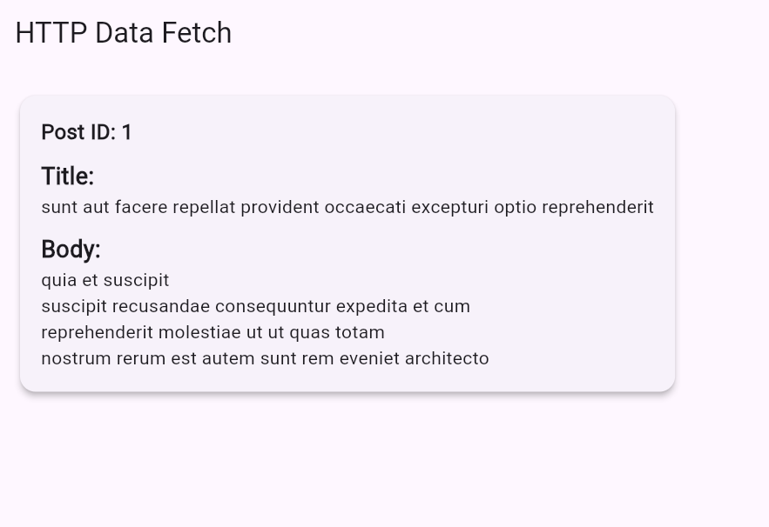

RESULT:
The Flutter application successfully retrieved data from a REST API using HTTP and displayed the fetched data dynamically on the screen.

